Prioritizing management goals for stream biological integrity within the developed landscape context

Marcus W. Beck ([marcusb@sccwrp.org](mailto:marcusb@sccwrp.org)), Raphael D. Mazor ([raphaelm@sccwrp.org](mailto:raphaelm@sccwrp.org)), Scott Johnson ([scott@aquaticbioassay.com](mailto:scott@aquaticbioassay.com)), Karin Wisenbaker ([karin@aquaticbioassay.com](mailto:karin@aquaticbioassay.com)), Joshua Westfall ([jwestfall@lacsd.org](mailto:jwestfall@lacsd.org)), Peter R. Ode ([peter.ode@wildlife.ca.gov](mailto:peter.ode@wildlife.ca.gov)), Ryan Hill ([hill.ryan@epa.gov](mailto:hill.ryan@epa.gov)), Chad Loflen ([Chad.Loflen@waterboards.ca.gov](mailto:Chad.Loflen@waterboards.ca.gov)), Martha Sutula ([marthas@sccwrp.org](mailto:marthas@sccwrp.org)), Eric D. Stein ([erics@sccwrp.org](mailto:erics@sccwrp.org))

# Supplement

# Case study: Application of the model to the San Gabriel River watershed

The San Gabriel River (SGR) Regional Monitoring Program (Los Angeles County, California) includes stakeholders from water quality regulatory agencies, municipalities, and non-governmental organizations that cooperatively work to manage aquatic resources in the watershed and improve coordination of compliance and ambient monitoring efforts. A strong land-use gradient occurs in the SGR watershed that creates challenges for managing stream condition (Fig. S4b). The upper watershed in the San Gabriel mountains is largely undeveloped or protected for recreational use, whereas the lower watershed is in a heavily urbanized region of Los Angeles County. The SGR is dammed at four locations in the upper watershed for flood control. Groundwater recharge areas are present in the middle of the watershed where water is allowed to spread beyond the main channel for subsurface infiltration during high flow events. As a result, the upper and lower watersheds are hydrologically disconnected when annual rainfall is normal. Nearly all of the stream segments in the lower half of the watershed are channelized with concrete or other reinforcements. The majority of flow in the lower watershed is provided to the mainstem and major tributaries of the SGR by wastewater treatment plants releasing tertiary treated effluent. Approximately half of the monitored sites in the watershed are in poor biological condition, nearly all of which are in the lower watershed.

Application of the model results to the CSCI scores provided biological predictions consistent with the strong land use gradient in the watershed (Fig. S5). Stream segments in the upper watershed were a mix of likely and possibly unconstrained (40% and 28%), whereas stream segments in the lower watershed were classified as likely and possibly constrained (25% and 7%). Several segments in the lower watershed had predicted median CSCI scores that were very close to the 10th percentile (i.e., right-skewed quantiles) consistent with extreme landscape pressures (bottom left, Fig. S5b).

The stakeholder group identified management priorities based on observed CSCI scores and results from the model. A template that showed how observed CSCI scores may compare (i.e., under-scoring, expected, over-scoring, or above/below biological objective) to segment classifications (i.e., constrained, unconstrained) was provided to the stakeholder to assign priorities among the various outcomes (rows 1-16, Fig. S6, left side) that could occur with actual data. The three priorities (Table S1) were then assigned a low, medium, or high importance for the scoring possibilities that could occur from the model (Fig. S2, right side). For sites without priority assignments, it was assumed that baseline monitoring and maintenance that is currently provided by existing management programs was sufficient for sustaining current biological condition. The final assignments were then mapped to each monitoring site in the watershed. Table S1 shows examples of the priority recommendations and sites for which they applied.

The SCAPE application allowed stakeholders to provide input on the two key decision points for classifying stream segments (i.e., choice of a threshold and range of predictions), as well as to assign priorities to each management action described above. The application then allowed stakeholders to see the outcomes of these decisions. Specifically, SCAPE created maps showing the classifications for segments in the watershed, deviation of observed CSCI scores from the expectation, and maps of recommended priority actions that were assigned to each of the scoring possibilities. In addition, the application tabulated the extent of streams in each class, as well as the number of sites prioritized for each management action. Crucially, SCAPE allowed the stakeholders to modify key decisions points in the model and rapidly evaluate how these changes propagated to changes in recommended priorities for each site.

The SCAPE application also allowed the stakeholders to identify spatial patterns among the watershed priorities. For example, a clear distinction between low and high priority actions was observed on the watershed map (Fig. S8). Sites in the lower watershed were lower priority if an action was recommended, whereas the five high priority sites were in the upper watershed (multiple recommendations were assigned to the sites). The distinction between lower and higher priorities between the lower and upper watershed was driven exclusively by the segment classifications, where constrained segments were in the lower watershed and unconstrained segments were in the upper watershed. Several sites that were scoring as expected for likely and possibly unconstrained segments in the upper watershed were recommended as medium priority for protection.

# Tecolote Creek example

Tecolote Creek (San Diego County, USA) was identified by our model as a constrained channel in an urban landscape (Fig. S9). The CSCI score is 0.61 indicating degraded biological integrity, but the channel is not modified. Other stressors originating at the landscape scale (e.g., water or sediment chemistry) have likely constrained the biological community at this site independent of the physical habitat quality.

# 

# Supplemental tables

Table 1: Recommended management actions defined by a local stakeholder group for application of results from the model to prioritize stream reaches. Actions were assigned to stream types based on observed CSCI scores relative to the stream expectation from the model (see Figs. S5, S6). Actions were recommended in addition to baseline monitoring and maintenance that occurred at all sites.

|  |  |  |  |
| --- | --- | --- | --- |
| Action | Example activity | Example high priority site | Example low priority site |
| Investigate | Higher frequency of sampling, evaluate additional data (e.g., habitat) | Sites scoring outside the range of predictions | Sites scoring as expected |
| Protect | Extra scrutiny of proposed impacts | Unconstrained sites | Constrained sites |
| Restore | Make funding recommendations, prioritize TMDL development | Low-scoring unconstrained sites | Low-scoring constrained sites |

# 

# Supplemental figures



Fig. 1: Relationship of predictor variables (watershed only, see Table 1) with stream classes. The top plot (A) shows boxplot distributions (median, interquartile ranges, and outliers) and the bottom plot (B) shows the relationship with CSCI scores. All x-axes are in log-scale.



Fig. 2: Model performance statewide and by major regions in California. Results are grouped by calibration (Cal) and validation (Val) datasets. Blue lines indicate the regression fit and black lines indicate correspondene between observations and predictions. CV = Central Valley, CH = Chaparral, DM = Deserts and Modoc Plateau, NC = North Coast, SN = Sierra Nevada, SC = South Coast.



Fig. 3: Model performance in relation to land cover and land cover by major regions in California. Model residuals (CSCI observed - predicted) were smaller in regions with more urban or agricultural land use (e.g., SC, CV) and larger in regions with less anthropogenic land use (e.g., SN, DM). CV = Central Valley, CH = Chaparral, DM = Deserts and Modoc Plateau, NC = North Coast, SN = Sierra Nevada, SC = South Coast.



Fig. 4: San Gabriel River watershed in southern California. Land cover is shown in plot (A) and the predicted median CSCI scores at each stream segment and observed CSCI scores are shown in (B).



Fig. 5: Application of the model to stream segments in the San Gabriel River watershed, Los Angeles County, California. CSCI scores with (A) context from the model are on the left and (B) no biological context from the model are on the right. Relative site scores as under-scoring, expected, or over-scoring are based on observed scores given the segment class as likely constrained, possibly constrained, possibly unconstrained, and likely unconstrained. Segment classes are based on overlap of the expectations with a biological threshold for the CSCI (0.79, dashed lined) and location of the median expectation (white ticks).



Fig. 6: Template provided to stakeholders for prioritization of recommended actions for each stream type. The site types relate to the stream class for the biological prediction (likely unconstrained, possibly unconstrained, possibly constrained, likely constrained), relative site score for the observed CSCI (over-scoring, expected, under-scoring), and location of the score relative to a hypothetical biological threshold (dashed line, above or below). Horizontal lines are the ranges of predicted CSCI scores for a site with tick marks for the median. Priority actions defined by stakeholders are shown on the right for each stream type (text descriptions in Table S1). Actions are generalized as investigate, protect, or monitor as high (H), medium (M), or low (L) priority. Blank cells indicate that no additional measures are recommended beyond the baseline monitoring and maintenance practiced at all sites.

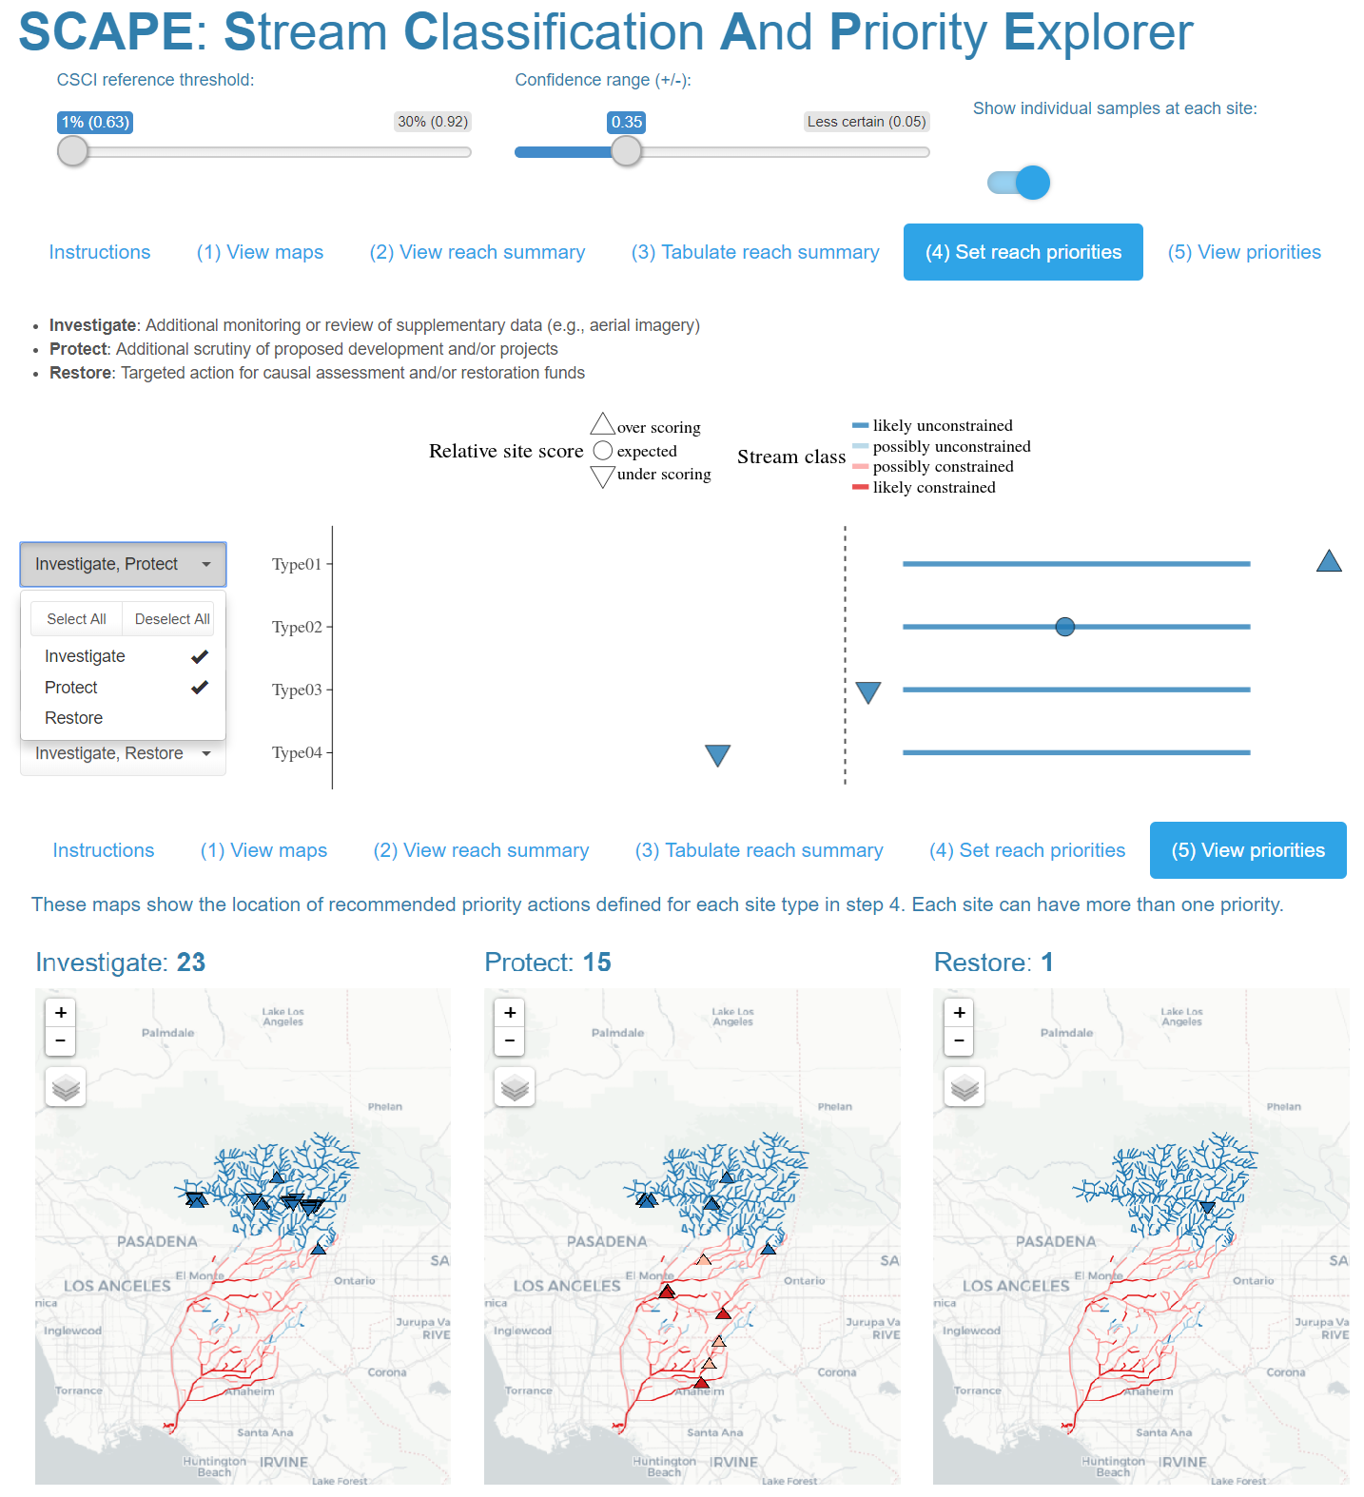

Fig. 7: Screenshots from the Stream Classification and Priority Explorer (SCAPE) tool used by the stakeholder group to interact with and use results from the model. The application allowed users to visualize results of segment classifications, relative site scores for the CSCI based on the expectation, and recommend management actions for each segment type. The app is accessible at <http://shiny.sccwrp.org/scape/>.



Fig. 8: Relative site scores and recommended management actions for locations with CSCI scores in the San Gabriel River watershed. Relative site scores as under scoring, expected, or over scoring are based on observed scores given the segment class as likely constrained, possibly constrained, possibly unconstrained, and likely unconstrained. Recommended management actions were defined by a local stakeholder group (see Fig. S6, Table S1) and are ranked by priority for actions to investigate, protect, and restore a site. No recommended actions assume baseline maintenance and monitoring is sufficient.

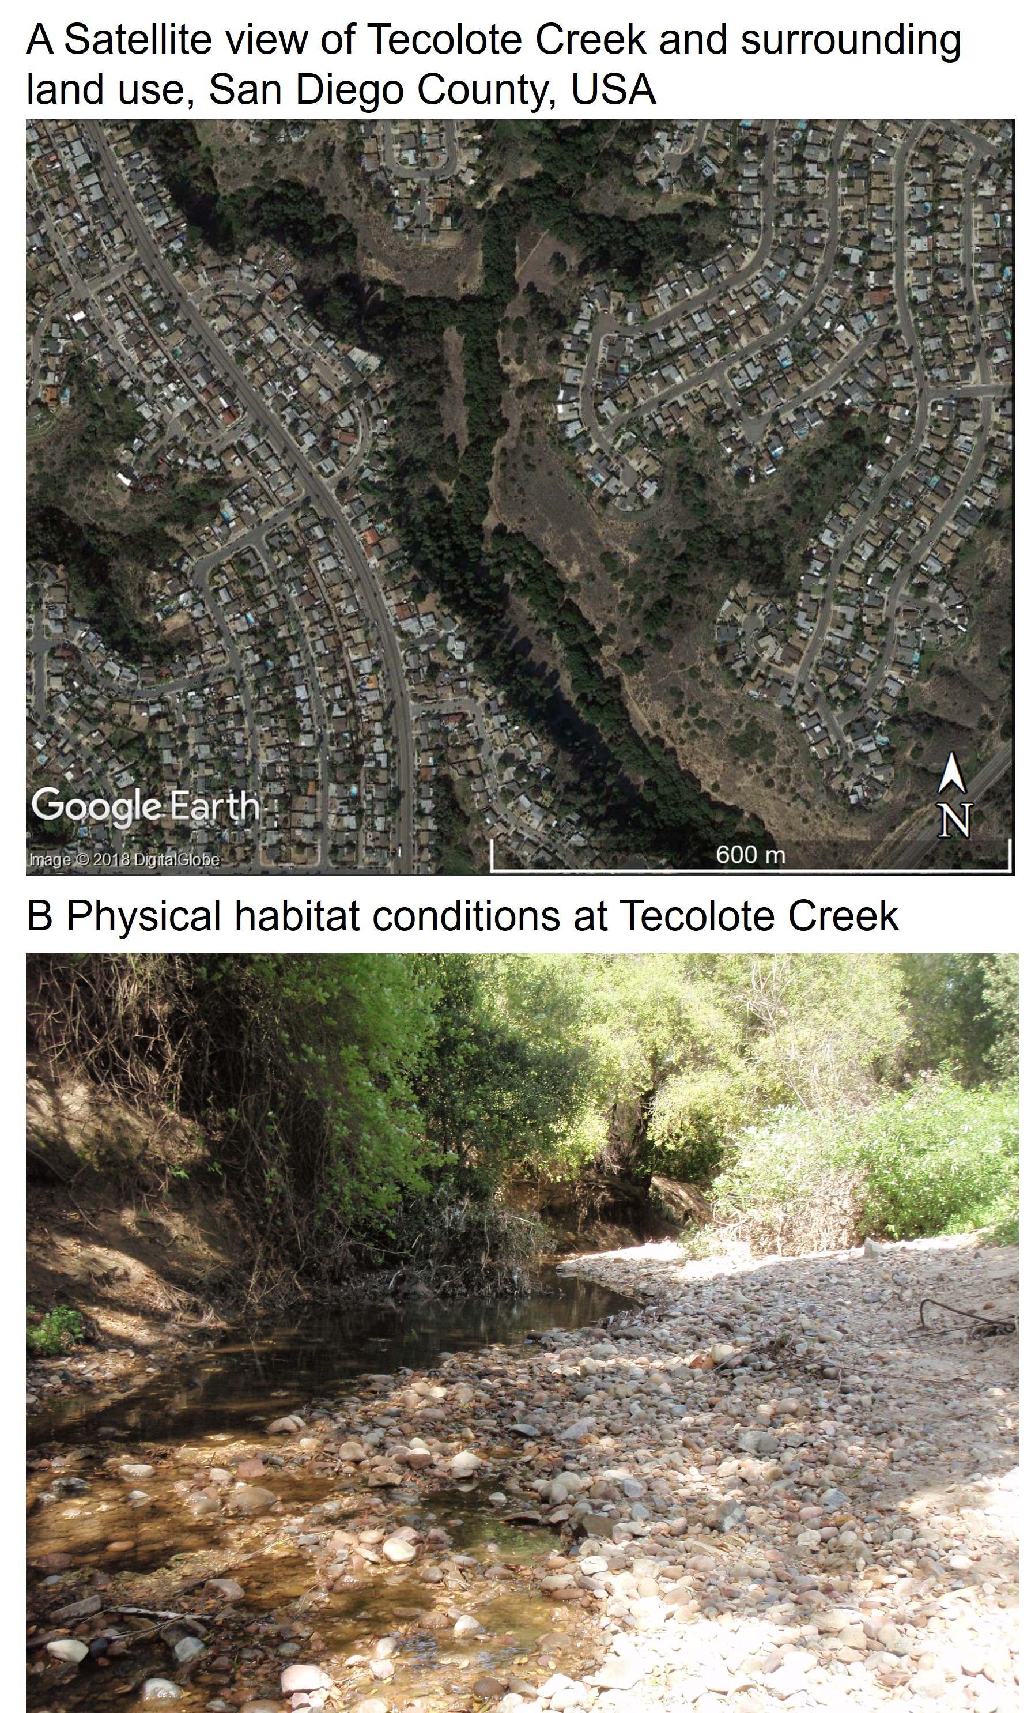

Fig. 9: Tecolote Creek (San Diego County, USA) is a constrained channel in an urban landscape (A, Source: 32.81736, -117.19986. Google Earth. November 8, 2016. Accessed July 20, 2018.). Physical habitat (B, Source: R. Mazor) at the sample site suggests no channel alteration. The CSCI was scored at 0.61 indicating degraded biological integrity.